Smart Property Management System
Phase 3 — Designing the Modules

5. Module Design
5.1 Introduction
Chapter 3 specified the system-level design: the four-tier layered architecture, the domain model, the database schema, and the interaction sequence diagrams. Phase 3 refines that design to the module level, specifying each module's purpose, public interface, dependencies, internal algorithms and error-handling behaviour to a level of detail sufficient for direct translation into code during Phase 4.
The ten modules identified during the decomposition are grouped into four architectural tiers, consistent with the layering introduced in Section 3.1:
Tier | Modules
Persistence | Module 1 — Database Foundation
Domain | Modules 2 — 10 (services)
Application | Controllers for Modules 2 — 10
Presentation | UI screens for Modules 2 — 10
Cross-cutting | Scheduler + Email (component of Module 10)

5.2 Module Decomposition Map
The following diagram expresses module dependencies. An edge A → B indicates that module A uses services exposed by module B.
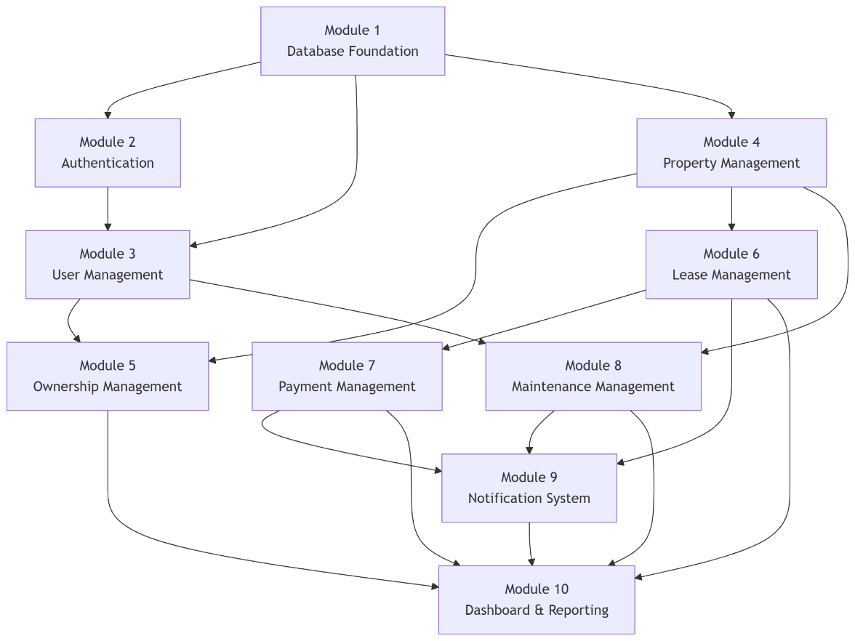

5.3 Module Interface Contract
Each module exposes a service façade — a single Python class whose public methods define its contract. Modules never call each other's repositories directly; they call services. This preserves tier isolation and enables independent unit-testing of each module with mock repositories.
The common interface convention adopted across all service modules is:
Return shape | Meaning
(True, result) | Operation succeeded; result is the created/updated entity or value
(False, error_message) | Operation rejected; message suitable for user display
list / int / entity | Simple query result; no failure case modelled
Errors are never raised across module boundaries as exceptions; they are returned as the second element of a tuple so that the UI layer can present them directly to the user without try/except clutter.

5.4 Module 1 — Database Foundation
5.4.1 Purpose
Provide a single, controlled access point to the relational store, encapsulating engine construction, session lifecycle, transaction boundaries, and schema evolution.
5.4.2 Responsibilities
- Construct the SQLAlchemy engine from a single configuration source (Database/config.py)
- Expose a scoped session factory used by repositories
- Define the declarative Base from which all entities inherit
- Create all tables on first run (idempotent)
- Seed a controlled dataset for development and demonstration
5.4.3 Public Interface
Symbol | Signature | Behaviour
get_session | () -> Session | Returns a thread-scoped SQLAlchemy session
engine | module attribute | Shared engine instance
Base | declarative base | All entity classes inherit
create_tables | () -> None | Issues CREATE TABLE for every registered model
seed_demo_data | () -> None | Inserts admin, owner, tenant, two properties, one lease, one payment, one maintenance request; no-op if any user exists
5.4.4 Dependencies
None — this is the bottom of the stack.
5.4.5 Class Diagram
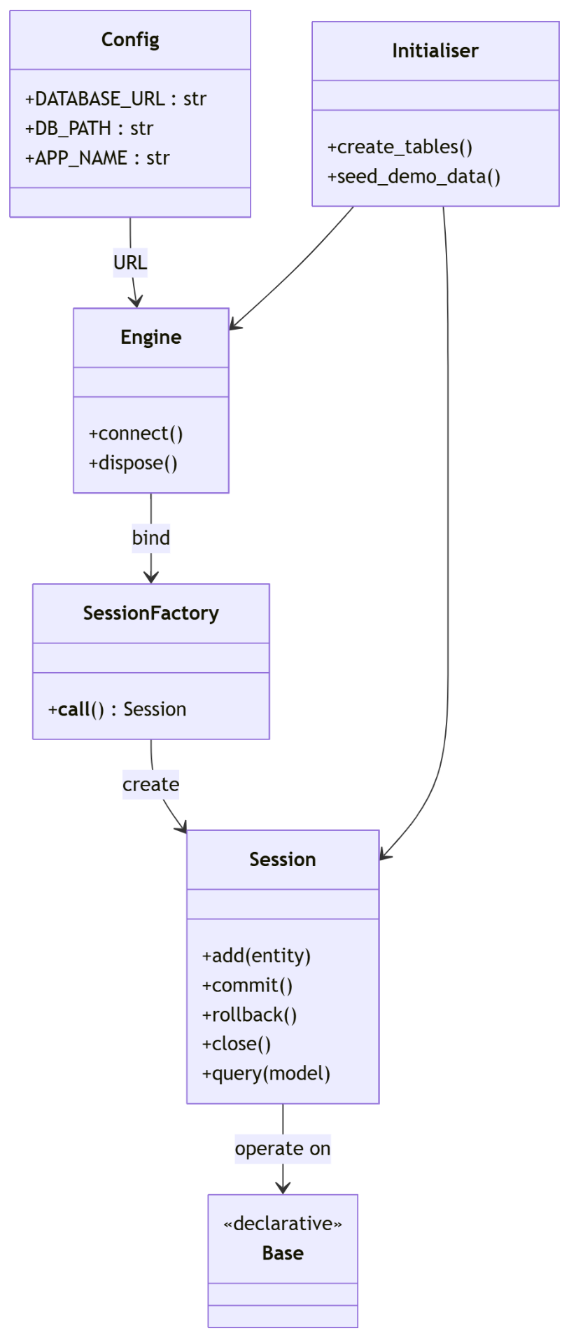
5.4.6 Business Rules
- Database URL is defined in exactly one place — Database/config.py.
- Switching from SQLite to PostgreSQL is a URL swap only; no application code changes.
- Seeding is idempotent: it exits cleanly if any user record already exists.
5.4.7 Error Handling
- Database file corruption → SQLAlchemy OperationalError; caller (repository) surfaces as (False, "Database unavailable")
- Unique constraint violations → caught at service layer, never reaches UI as a raw exception
5.4.8 Traceability
Requirement | Satisfied by
R-Core-01 Persistent storage | Engine + Session
R-Core-02 Referential integrity | Model FK definitions
R-NFR-01 Portable database | Config-driven URL

5.5 Module 2 — Authentication & Authorisation
5.5.1 Purpose
Verify user identity against stored credentials, enforce role selection consistency, and return a serialised user object for the presentation layer.
5.5.2 Responsibilities
- Hash passwords with bcrypt at registration and seeding time
- Verify supplied passwords against stored hashes using constant-time comparison
- Accept login by email or national ID number
- Reject login when the user's stored role does not match the role card selected on the User Type screen
- Clear the login form when the user navigates away or logs out
5.5.3 Public Interface
Class | Method | Signature
Security | hash_password | (plain: str) -> str
Security | verify_password | (plain: str, hashed: str) -> bool
UserRepository | find_by_login | (identifier: str) -> User | None
AuthService | authenticate | (identifier, password, expected_role) -> (bool, dict | None, str | None)
AuthService | register | (id_number, name, email, phone, password, role) -> (bool, str)
AuthController | login | (identifier, password, selected_role) -> (bool, dict | None, str | None)
5.5.4 Dependencies
Module 1 (Database, User entity), bcrypt.

5.5.5 Class Diagram
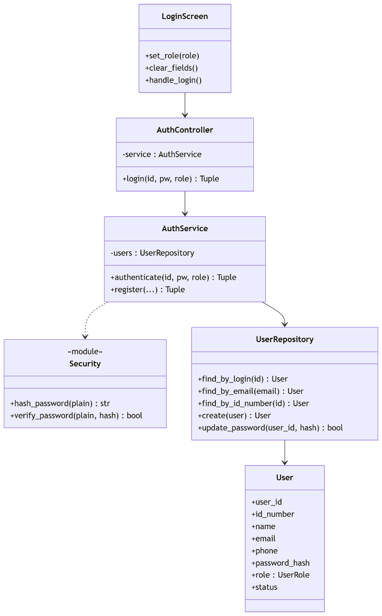
5.5.6 Algorithm — Authenticate
text
Inputs: identifier, password, expected_role
Output: (ok, user_dict, error)

1. If identifier is empty or password is empty:
return (False, None, "Please enter both your ID/email and password.")
2. user ← UserRepository.find_by_login(identifier.strip())
3. If user is None:
return (False, None, "No account found with those details.")
4. If not Security.verify_password(password, user.password_hash):
return (False, None, "Incorrect password.")
5. If expected_role is set and user.role ≠ ROLE_MAP[expected_role]:
return (False, None, "This account is not registered as {expected_role}.")
6. Return (True, user.to_dict(), None)
5.5.7 Business Rules
- Passwords are truncated to 72 bytes before bcrypt hashing (bcrypt's hard limit).
- Failure messages are deliberately specific for this academic system (documented trade-off: real systems should use generic messages to prevent account enumeration).
- Role lookup is case-insensitive on the map key but the map covers exactly the four role strings emitted by the User Type screen.
- On success, only the password field is cleared — the identifier remains so a returning user can log in again quickly.
5.5.8 Traceability
Requirement | Satisfied by
R-Core-10 Secure login | AuthService.authenticate
R-Core-11 Role-based access | Role gate in step 5
R-NFR-03 Password confidentiality | bcrypt hashing

5.6 Module 3 — User Management
5.6.1 Purpose
Allow administrators to create, view, filter, edit and deactivate user accounts across all roles.
5.6.2 Responsibilities
- Provide a filterable table of users
- Enforce unique email and unique national ID number
- Hash passwords at creation and on password reset
- Prevent hard deletion when a user has associated leases or ownerships (offer deactivation instead)
- Restrict all write operations to UserRole.ADMIN
5.6.3 Public Interface
Class | Method | Signature
UserService | list_users | (filters: dict) -> list[dict]
UserService | create_user | (data: dict, session: User) -> (bool, str)
UserService | update_user | (user_id: int, data: dict, session: User) -> (bool, str)
UserService | deactivate_user | (user_id: int, session: User) -> (bool, str)
UserService | reactivate_user | (user_id: int, session: User) -> (bool, str)
5.6.4 Dependencies
Module 1 (User entity), Module 2 (Security.hash_password).

5.6.5 Class Diagram
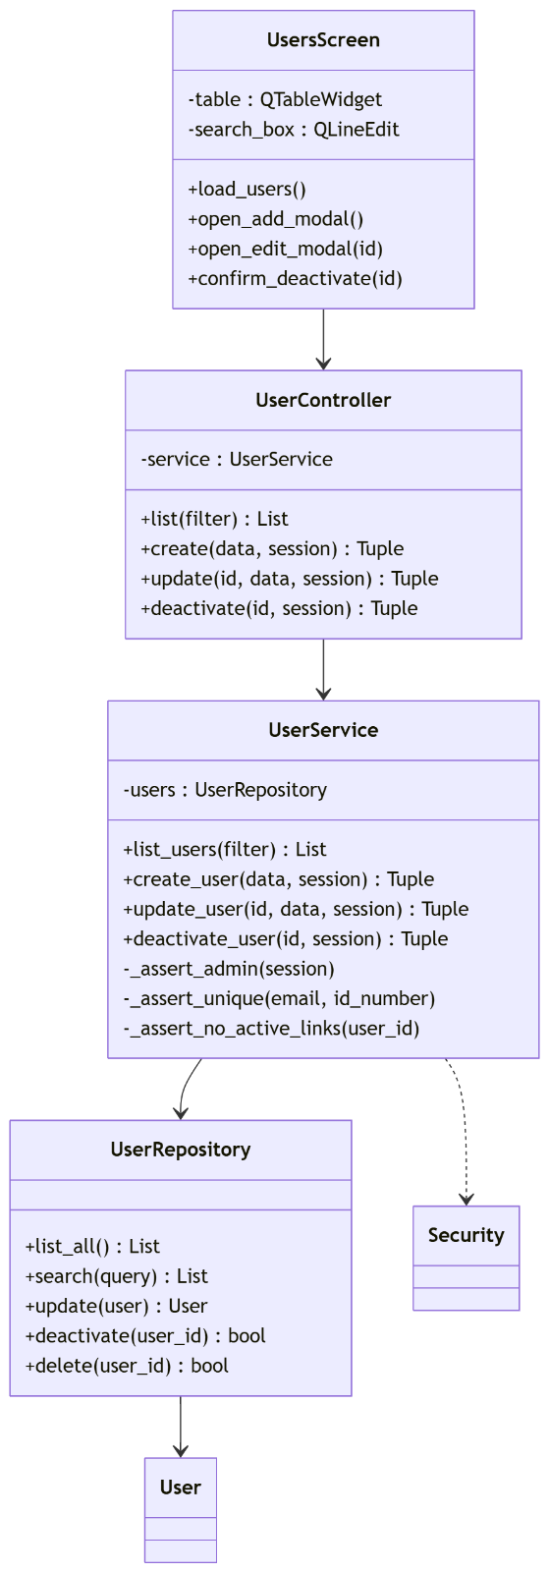
5.6.6 Business Rules
- session.role must equal UserRole.ADMIN for any write operation.
- email and id_number must be unique — enforced by the service before insert.
- Deactivation sets status = "Inactive"; the login module rejects inactive accounts.
- Hard delete is permitted only when the user has no Ownership, Lease, or MaintenanceRequest records.
5.6.7 Traceability
Requirement | Satisfied by
R-Core-20 Admin manages users | UserService write methods
R-Core-21 Account deactivation | deactivate_user
R-NFR-05 Auditability | Retention of user rows on deactivation

5.7 Module 4 — Property Management
5.7.1 Purpose
Manage the lifecycle of property records from registration through occupancy to archival.
5.7.2 Responsibilities
- CRUD operations on Property entities
- Enforce controlled vocabulary for property_type and status
- Recalculate status automatically in response to lease and maintenance events
- Restrict writes to Administrator and Property Manager roles
- Prevent hard deletion of a property with an active lease
5.7.3 Public Interface
Class | Method | Signature
PropertyService | list_properties | (filters: dict) -> list[dict]
PropertyService | create_property | (data: dict, session: User) -> (bool, str)
PropertyService | update_property | (property_id: int, data: dict, session: User) -> (bool, str)
PropertyService | archive_property | (property_id: int, session: User) -> (bool, str)
PropertyService | recalculate_status | (property_id: int) -> str
5.7.4 Dependencies
Module 1; reads from LeaseRepository and MaintenanceRepository for status recalculation.
5.7.5 Class Diagram
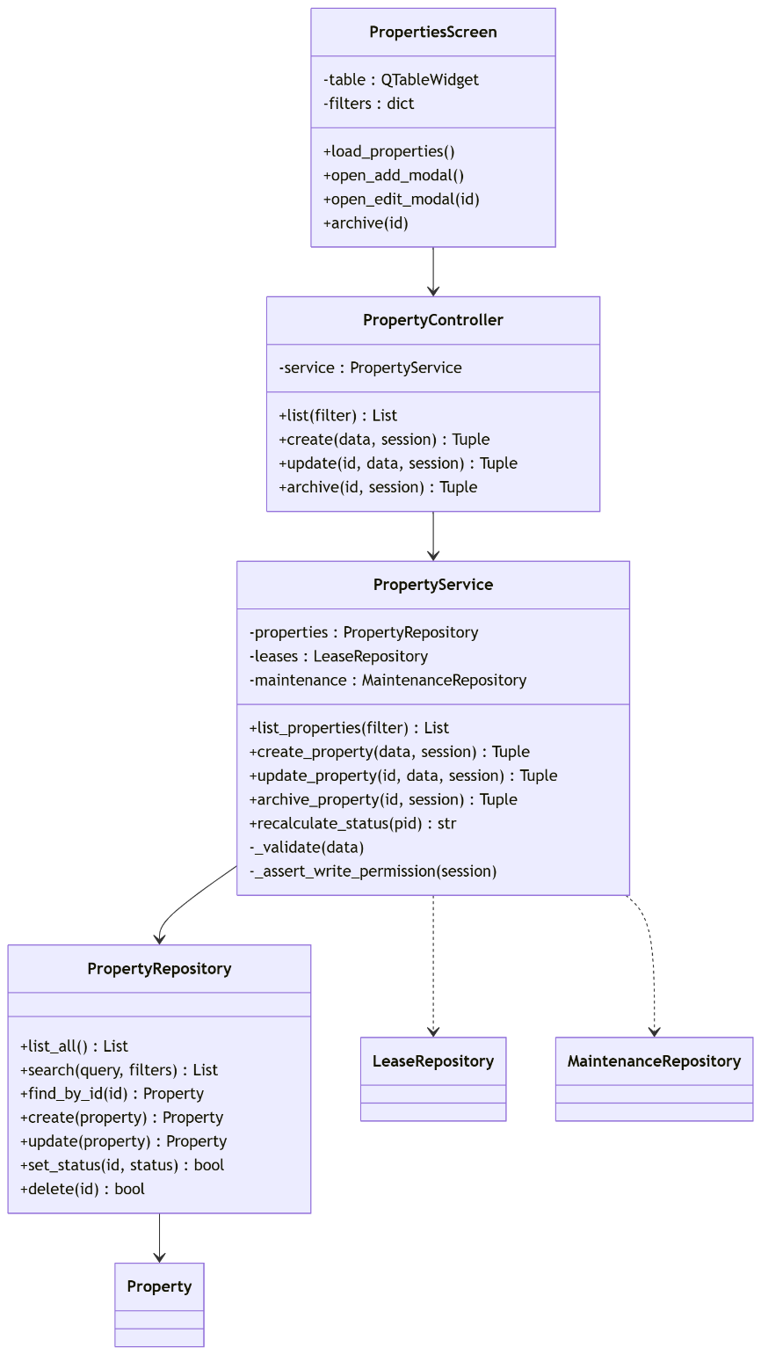
5.7.6 Algorithm — Status Recalculation
text
Input: property_id
Output: new status string

1. If LeaseRepository.has_active_lease(property_id):
new_status ← "Occupied"
2. Else if MaintenanceRepository.has_open_request(property_id):
new_status ← "Under Maintenance"
3. Else:
new_status ← "Available"
4. PropertyRepository.set_status(property_id, new_status)
5. Return new_status
This algorithm is invoked from Module 6 (lease change) and Module 8 (maintenance closure).
5.7.7 Business Rules
- address is required and must be non-empty.
- property_type ∈ {House, Apartment, Commercial, Other}.
- status ∈ {Available, Occupied, Under Maintenance, Archived}.
- Archive is a soft operation — the row remains for historical reporting.
5.7.8 Traceability
Requirement | Satisfied by
R-Core-30 Property CRUD | PropertyService
R-Core-31 Status tracking | recalculate_status

5.8 Module 5 — Ownership Management
5.8.1 Purpose
Model and maintain ownership relationships between users and properties, with support for co-ownership, percentage shares, and historical continuity.
5.8.2 Responsibilities
- Attach one or more owners to a property
- Record each owner's share such that the sum of active shares never exceeds 1.0
- Reject ownership where the target user does not hold the Owner role
- Preserve historical records by closing them with an end date rather than deleting
5.8.3 Public Interface
Class | Method | Signature
OwnershipService | list_for_property | (property_id: int) -> list[dict]
OwnershipService | add_ownership | (data: dict, session: User) -> (bool, str)
OwnershipService | end_ownership | (ownership_id: int, end_date: date, session: User) -> (bool, str)
OwnershipService | active_share_total | (property_id: int) -> float
5.8.4 Dependencies
Modules 1, 3, 4.

5.8.5 Class Diagram
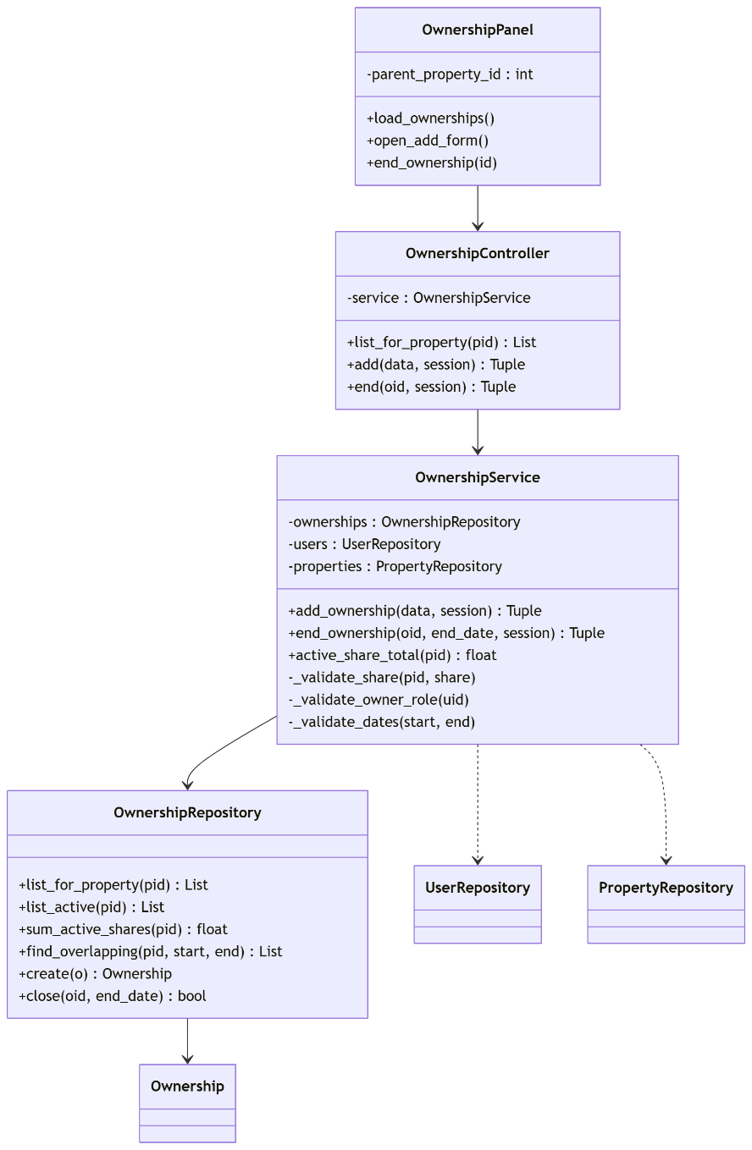
5.8.6 Algorithm — Add Ownership
text
Input: property_id, user_id, share, start_date, end_date
Output: (ok, error)

1. user ← UserRepository.find_by_id(user_id)
2. If user.role ≠ OWNER:
return (False, "Only owners can be assigned ownership")
3. If end_date is set and start_date ≥ end_date:
return (False, "End date must be after start date")
4. current_total ← OwnershipRepository.sum_active_shares(property_id)
5. If current_total + share > 1.0:
return (False, "Total ownership shares would exceed 100%")
6. OwnershipRepository.create(property_id, user_id, share, start, end)
7. Return (True, None)
5.8.7 Business Rules
- Active shares for a property at any instant ≤ 1.0.
- Only users with UserRole.OWNER may be assigned ownership.
- Ending ownership is a soft operation — end_date is set; the row is preserved.
5.8.8 Traceability
Requirement | Satisfied by
R-Core-40 Ownership recording | OwnershipService.add_ownership
R-Core-41 Co-ownership support | Share field + sum constraint

5.9 Module 6 — Lease Management
5.9.1 Purpose
Create, manage and terminate lease agreements between property owners and tenants, and detect leases approaching expiry.
5.9.2 Responsibilities
- Create leases linking a property to a tenant with a rent amount and date range
- Enforce the constraint that a property may have only one active lease at a time
- Generate the first payment record on lease creation (delegates to Module 7)
- Trigger property status recalculation on lease creation or termination
- Provide an expiry-detection query for the scheduler
5.9.3 Public Interface
Class | Method | Signature
LeaseService | list_leases | (filters: dict) -> list[dict]
LeaseService | create_lease | (data: dict, session: User) -> (bool, str)
LeaseService | terminate_lease | (lease_id: int, session: User) -> (bool, str)
LeaseService | check_expiring | (threshold_days: int = 30) -> list[dict]
5.9.4 Dependencies
Modules 1, 4 (property), 3 (tenant existence), 7 (initial payment), 9 (notifications).
5.9.5 Class Diagram
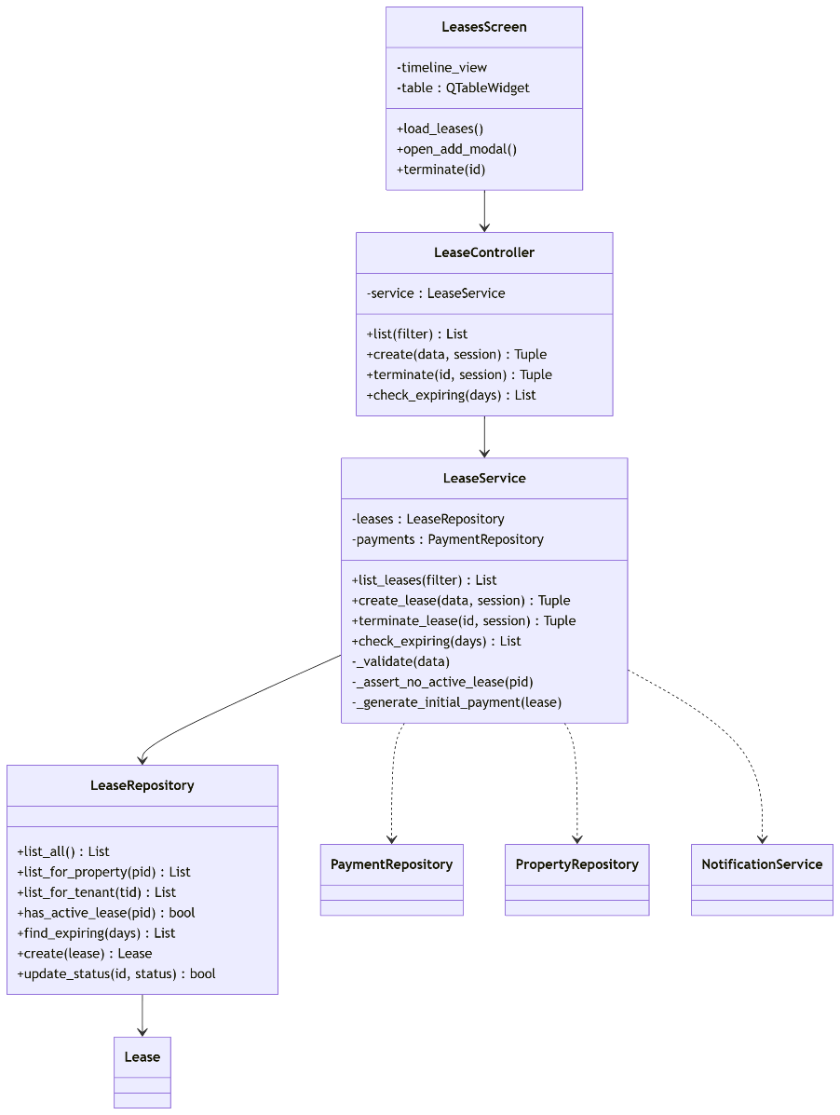

5.9.6 Algorithm — Create Lease
text
Input: property_id, tenant_id, start_date, end_date, rent_amount
Output: (ok, error)

1. If rent_amount ≤ 0:
return (False, "Rent must be greater than zero")
2. If start_date ≥ end_date:
return (False, "Start date must be before end date")
3. If LeaseRepository.has_active_lease(property_id):
return (False, "Property already has an active lease")
4. lease ← LeaseRepository.create(...)
5. PaymentRepository.create(lease_id=lease.lease_id,
amount=lease.rent_amount,
due_date=start_date,
status="Pending")
6. PropertyService.recalculate_status(property_id)
7. Return (True, None)
5.9.7 Business Rules
- A property may hold at most one status = "Active" lease at any time.
- Terminating a lease sets status to "Terminated" and recalculates the property status.
- check_expiring is purely a query — the notifications are emitted by the scheduler task in Module 10, not by the service.
5.9.8 Traceability
Requirement | Satisfied by
R-Core-50 Lease CRUD | LeaseService
R-Core-51 Lease expiry alert | check_expiring + Module 10 task
R-Core-52 Payment on lease creation | _generate_initial_payment

5.10 Module 7 — Payment Management
5.10.1 Purpose
Track rent payments against leases, mark them paid, and automatically identify overdue payments.
5.10.2 Responsibilities
- Persist payment records tied to a lease
- Mark a payment as paid with a paid_date
- Detect overdue payments (due date in the past and status not Paid) and transition them to Overdue
- Emit overdue notifications via Module 9
5.10.3 Public Interface
Class | Method | Signature
PaymentService | list_payments | (filters: dict) -> list[dict]
PaymentService | create_payment | (data: dict, session: User) -> (bool, str)
PaymentService | mark_paid | (payment_id: int, paid_date: date, session: User) -> (bool, str)
PaymentService | check_overdue | () -> int
5.10.4 Dependencies
Modules 1, 6 (Lease), 9 (Notification).

5.10.5 Class Diagram
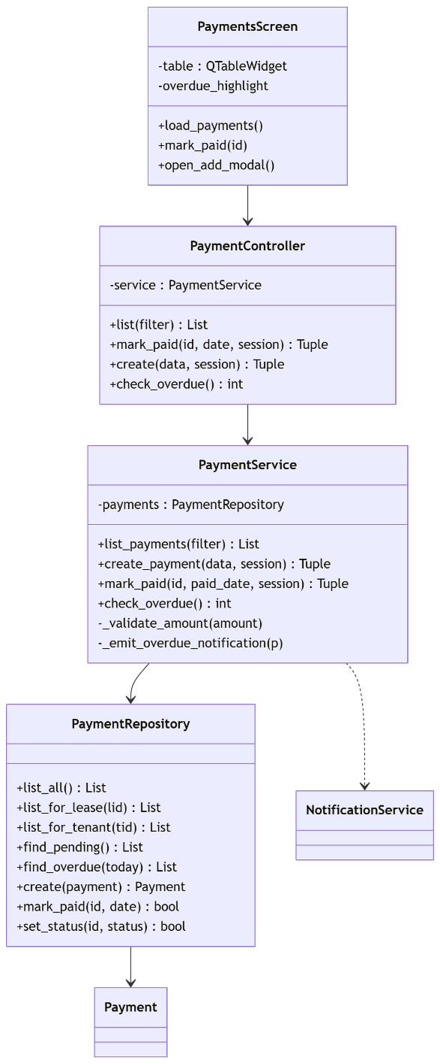
5.10.6 Algorithm — Overdue Detection
text
Output: count of newly-overdue payments

1. today ← date.today()
2. newly_overdue ← 0
3. For each payment in PaymentRepository.find_pending():
If payment.due_date < today:
PaymentRepository.set_status(payment.payment_id, "Overdue")
NotificationService.emit(
user_id = payment.lease.tenant_id,
type = "payment_overdue",
title = "Payment overdue",
message = "Payment #{id} was due on {due_date}"
)
newly_overdue += 1
4. Return newly_overdue
5.10.7 Business Rules
- Amount must be strictly positive.
- Once marked paid, a payment cannot be reverted to Pending through the UI.
- Overdue detection is idempotent — running it repeatedly produces no duplicate notifications because the status transition only fires once.
5.10.8 Traceability
Requirement | Satisfied by
R-Core-60 Payment recording | PaymentService.create_payment
R-Core-61 Overdue detection | check_overdue

5.11 Module 8 — Maintenance Management
5.11.1 Purpose
Enable tenants to submit maintenance requests for properties they lease, and enable managers to track, prioritise and close those requests.
5.11.2 Responsibilities
- Validate that a tenant submitting a request has an active lease on the referenced property
- Enforce the state machine Open → In Progress → Resolved → Closed, with permitted rework transitions
- Notify the submitter and the property owner on status change
- Trigger property status recalculation on closure
5.11.3 Public Interface
Class | Method | Signature
MaintenanceService | list_requests | (filters: dict) -> list[dict]
MaintenanceService | submit_request | (data: dict, session: User) -> (bool, str)
MaintenanceService | update_status | (request_id: int, new_status: str, session: User) -> (bool, str)
5.11.4 Dependencies
Modules 1, 3, 4, 6, 9.

5.11.5 Class Diagram
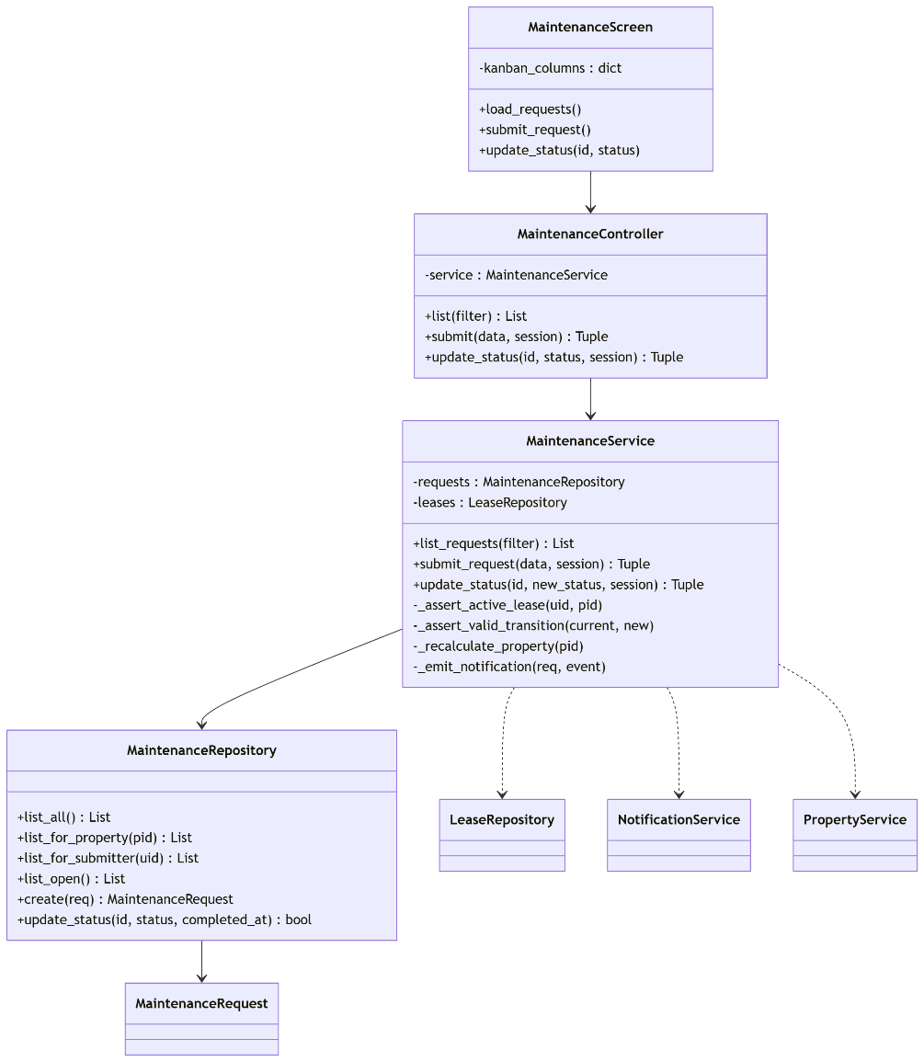
5.11.6 Algorithm — Status Transition
text
Allowed transitions:
Open → [In Progress]
In Progress → [Resolved]
Resolved → [Closed, In Progress]
Closed → []

Input: request_id, new_status
Output: (ok, error)

1. req ← MaintenanceRepository.find_by_id(request_id)
2. If new_status ∉ ALLOWED[req.status]:
return (False, "Invalid transition from {req.status} to {new_status}")
3. If new_status = "Closed":
MaintenanceRepository.update_status(id, "Closed", completed_at=now())
PropertyService.recalculate_status(req.property_id)
4. Else:
MaintenanceRepository.update_status(id, new_status, completed_at=None)
5. NotificationService.emit(to=req.submitted_by, type="maintenance_update", ...)
6. Return (True, None)
5.11.7 Business Rules
- Description must be non-empty.
- Priority ∈ {Low, Medium, High, Urgent}.
- Only Manager or Administrator may change priority or close a request.
- On close, completed_at is set.
5.11.8 Traceability
Requirement | Satisfied by
R-Core-70 Submit maintenance | submit_request
R-Core-71 Status transitions | update_status

5.12 Module 9 — Notification & Preference System
5.12.1 Purpose
Centralise all system events into user-facing notifications, and provide per-user control over delivery channels.
5.12.2 Responsibilities
- Persist Notification records produced by any other module
- Track read/unread state via a nullable read_at timestamp
- Expose unread count and unread-first list
- Store per-user, per-event-type preferences
- Route notifications through the correct channels (dashboard, email) at emit time
- Queue outbound emails when email delivery is enabled
5.12.3 Public Interface
Class | Method | Signature
NotificationService | emit | (user_id, type, title, message, priority="Normal") -> Notification
NotificationService | list_for_user | (user_id: int) -> list[dict]
NotificationService | mark_read | (notification_id: int) -> bool
NotificationService | unread_count | (user_id: int) -> int
PreferenceService | get | (user_id, event_type) -> NotificationPreference
PreferenceService | set | (user_id, event_type, prefs: dict) -> bool
5.12.4 Dependencies
Module 1 (entities), Module 10 (EmailService.queue).

5.12.5 Class Diagram
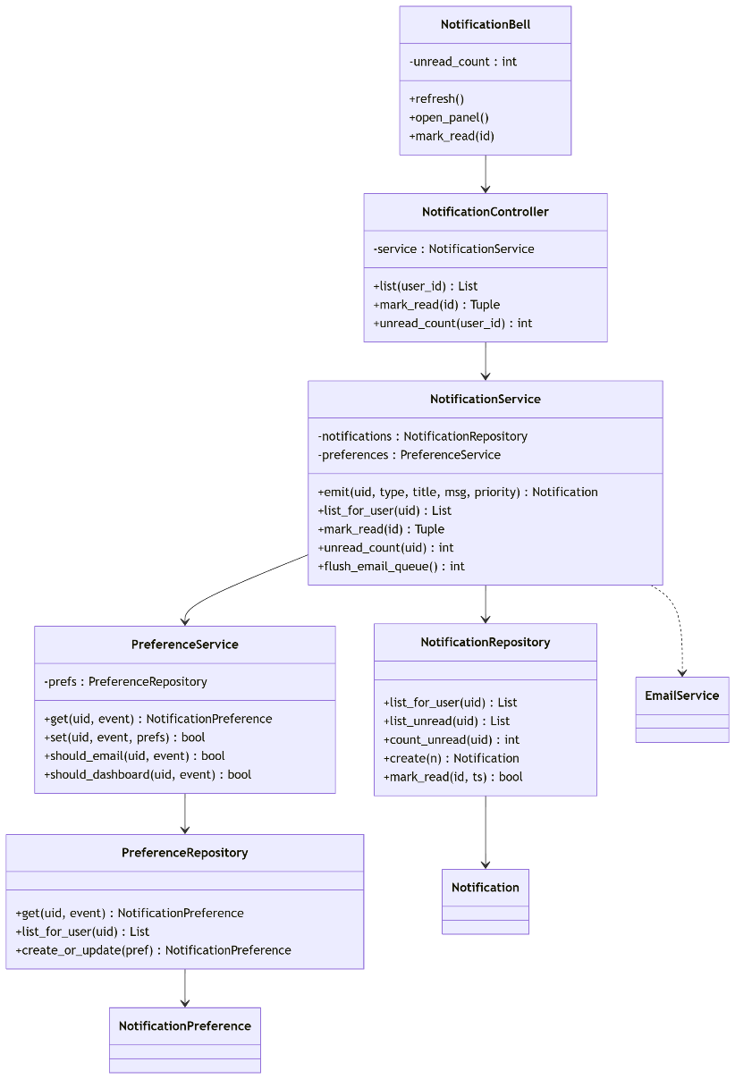
5.12.6 Algorithm — Emit
text
Input: user_id, type, title, message, priority
Output: persisted Notification

1. pref ← PreferenceService.get(user_id, type)
(falls back to defaults if no explicit preference row exists)
2. n ← Notification(user_id, type, title, message, priority,
created_at=now(), read_at=None)
3. NotificationRepository.create(n)
4. If pref.email_enabled:
EmailService.queue(n)
5. If pref.dashboard_enabled:
(dashboard reads unread_count on next refresh — no push needed)
6. Return n
5.12.7 Business Rules
- A notification row is always persisted, regardless of channel preference. Preference controls delivery, not persistence.
- read_at IS NULL identifies unread notifications; this single nullable column is sufficient and index-friendly.
- Email delivery is a queued operation — failures in the email subsystem never block a user action.
5.12.8 Traceability
Requirement | Satisfied by
R-Core-80 In-app notifications | NotificationService.emit
R-Core-81 User preferences | PreferenceService
R-NFR-06 Non-blocking email | Queue design

5.13 Module 10 — Dashboard, Reporting & Email Dispatch
5.13.1 Purpose
Present role-aware aggregated data on the dashboard, produce downloadable reports, and run the daily scheduled reminders that other modules depend on.
5.13.2 Responsibilities
- Aggregate statistics for the logged-in user's role
- Render charts and activity feed in the dashboard
- Generate PDF reports on demand
- Run the daily reminder task: lease expiry check, payment overdue check, email flush
- Dispatch queued emails via SMTP
5.13.3 Public Interface
Class | Method | Signature
DashboardService | aggregate_for | (user: dict) -> dict
ReportService | generate_property_report | (filter: dict) -> bytes
ReportService | generate_payment_report | (filter: dict) -> bytes
EmailService | send | (to, subject, body) -> bool
EmailService | queue | (notification) -> None
EmailService | flush | () -> int
Scheduler | start / stop | () -> None
ReminderTask | run | () -> None
5.13.4 Dependencies
All other modules (read side only).
5.13.5 Class Diagram
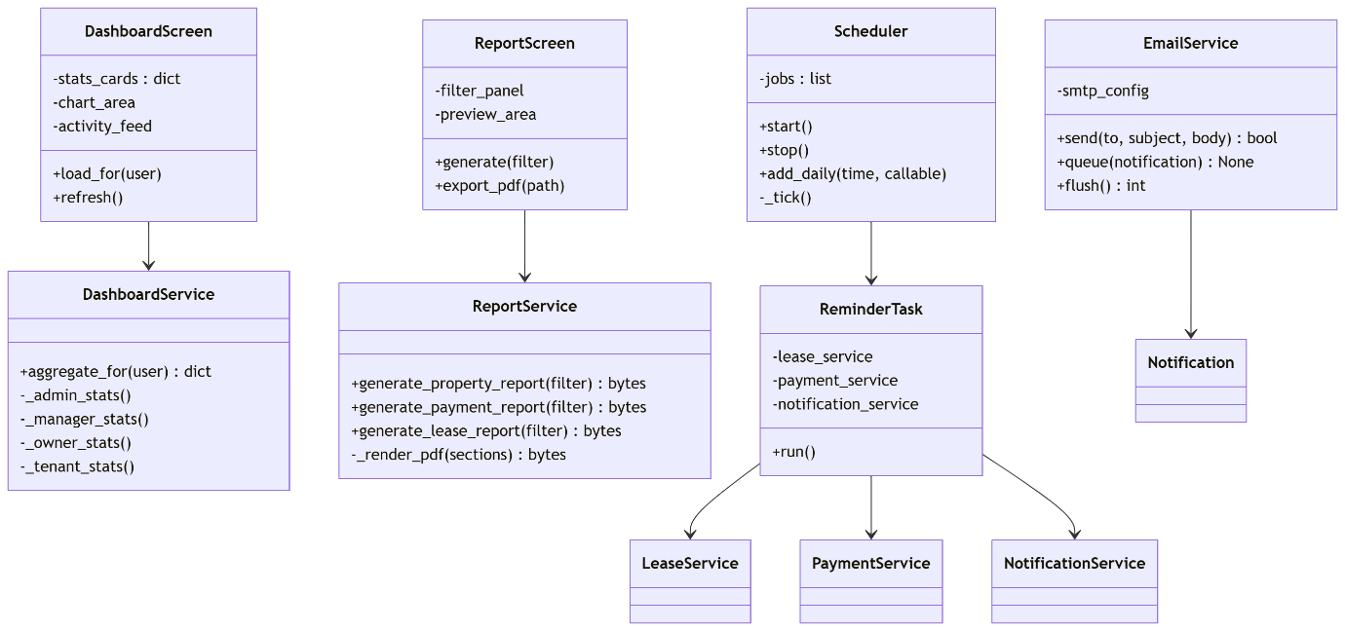
5.13.6 Algorithm — Role-Aware Aggregation
text
Input: user dict (contains user_id and role)
Output: stats dict

switch user.role:

case ADMIN:
stats = {
"users": count(User),
"properties": count(Property),
"active_leases": count(Lease where status="Active"),
"overdue_payments": count(Payment where status="Overdue")
}

case MANAGER:
stats = {
"properties_managed": count(Property),
"active_leases": count(Lease where status="Active"),
"open_maintenance": count(Maintenance where status IN ["Open","In Progress"]),
"upcoming_expiries": count(Lease where end_date ≤ today+30)
}

case OWNER:
owned ← [o.property_id for o in Ownership where user_id=user.id and end_date is null]
stats = {
"owned_properties": len(owned),
"active_leases": count(Lease where property_id ∈ owned and status="Active"),
"payments_due_month": sum(Payment.amount where lease.property_id ∈ owned
and status="Pending"
and month(due_date)=current_month)
}

case TENANT:
stats = {
"my_lease": Lease where tenant_id=user.id and status="Active",
"next_payment": earliest Payment where lease.tenant_id=user.id and status="Pending",
"my_open_issues": count(Maintenance where submitted_by=user.id and status != "Closed")
}

return stats
5.13.7 Algorithm — Scheduler Daily Job
text
Every day at 08:00 local:

1. LeaseService.check_expiring(30)
2. PaymentService.check_overdue()
3. EmailService.flush()

Email flush dequeues notifications from the outbound table and sends
them one at a time; failures are logged and retried on the next tick.
5.13.8 Business Rules
- Dashboard content is strictly role-scoped — no cross-role data leakage.
- Reports are written to Documentation/reports/ with a timestamped filename.
- Scheduler runs in a background thread; UI remains responsive.
- Email is optional — if SMTP credentials are absent, the flush step is skipped, and the system continues working with in-app notifications only.
5.13.9 Traceability
Requirement | Satisfied by
R-Core-90 Role-specific dashboard | aggregate_for
R-Core-91 Reports | ReportService
R-Core-92 Email reminders | EmailService + Scheduler

5.14 Cross-Module Interactions
The following three interactions summarise how modules cooperate at runtime. Each has been captured as a sequence diagram in Chapter 3; the Phase 3 description below names the modules involved.
Interaction | Modules involved | Trigger
Login | 2, 1 | User action
Add Property | 4, 1 | Manager action
Reminder Dispatch | 10, 6, 7, 9 | Scheduled task
Maintenance Lifecycle | 8, 6, 4, 9 | Tenant and manager actions

5.15 Module Dependency Graph
Ordered by dependency depth — a valid top-down implementation order for Phase 4:
Level | Modules
0 | 1 — Database Foundation
1 | 2 — Authentication
2 | 3 — User Management, 4 — Property Management
3 | 5 — Ownership, 6 — Lease, 8 — Maintenance
4 | 7 — Payment
5 | 9 — Notification System
6 | 10 — Dashboard, Reporting & Email

5.16 Requirements Traceability Matrix
Requirement ID | Description | Module(s) satisfying
R-Core-01 | Persistent storage | 1
R-Core-02 | Referential integrity | 1
R-Core-10 | Secure login | 2
R-Core-11 | Role-based access | 2, 3, 4, 6, 7, 8
R-Core-20 | Admin manages users | 3
R-Core-21 | Account deactivation | 3
R-Core-30 | Property CRUD | 4
R-Core-31 | Property status tracking | 4, 6, 8
R-Core-40 | Ownership recording | 5
R-Core-41 | Co-ownership support | 5
R-Core-50 | Lease CRUD | 6
R-Core-51 | Lease expiry alert | 6, 9, 10
R-Core-52 | Auto-generate initial payment | 6, 7
R-Core-60 | Payment recording | 7
R-Core-61 | Overdue detection | 7, 9, 10
R-Core-70 | Submit maintenance | 8
R-Core-71 | Status transitions | 8
R-Core-80 | In-app notifications | 9
R-Core-81 | User notification preferences | 9
R-Core-90 | Role-specific dashboard | 10
R-Core-91 | Reports | 10
R-Core-92 | Email reminders | 10
R-NFR-01 | Portable database | 1
R-NFR-02 | Layered architecture | all
R-NFR-03 | Password confidentiality | 2
R-NFR-05 | Auditability | 3
R-NFR-06 | Non-blocking email | 10

